**RESIT FINAL PROJECT**

**DATA ANALYTICS IN FINANCE**

**INTRODUCTION**

Over the past few decades, there have been many shifts in the financial services industry. On the one hand, the breadth of operations in the financial sector has risen significantly, covering a wide range of new banking, investment, and insurance products, together with new financing tools and corporate finance practices. However, the industry has become increasingly reliant on new technology as instruments for better decision making, risk analysis, monitoring, and reporting, as well as for improved service delivery to individual and corporate clients. Finally, certain shifts in the regulatory environment have mandated new standards for the development, distribution, and oversight of financial services.

Complexity in analytical tools and methodologies is often needed in the financial services industry to deal with the issues that arise as a result of these changes.

Historically, the development of theories in the field of finance has depended on normative and descriptive approaches, typically based on statistical and econometric methods. While financial theory is important, prescriptive and predictive systems are even more so because they offer practical advice to decision makers (investors, managers, policymakers) on concrete instances of financial decision problems. Financial decision-making is aided by such systems when they are combined with financial theory and models because of the all-encompassing ways in which they combine theory, data, and expert judgment.

However, the aforementioned financial services industry setting offers a number of hurdles to the advancement of credible and efficient analytic models and methods in this area. To begin, robust models must be developed and rigorously tested because of the presence of significant uncertainty. Second, although the importance of big data is rising in the financial sector, financial data are typically noisy and lack structure.

Complicating this need for real-time decision assistance is the fact that the sheer quantity of data poses computing challenges. Last but not least, reporting and supervisory supervision of the processes followed in the financial sector have become reliant on model transparency.

The purpose of this study is to review the state of the art and recent advances in this field with an emphasis on computational and data analytic methods. Given the breadth and depth of the field as well as the variety of analytical approaches, it is challenging to give a systematic evaluation of the relevant literature.

Next, we delve deeper into one trendy subfield of finance the debt maturity ratio by analyzing financial data. Analytical strategies are the primary focus of this review approaches, such as data mining and machine learning.

# LITERATURE REVIEW

Financing choices, investment strategy, and regulatory oversight are all examples of decision dilemmas that arise frequently in the financial services industry. Concerns about risk management in financial institutions have received the lion's share of attention in both academia and practice in recent years (banks, insurance companies, funds, etc.). Furthermore, the development of new electronic platforms and distribution channels (e.g., online transactions, crowdfunding, cryptocurrencies) has sparked a great deal of interest in problems concerning the design and management of financial services given to consumers and corporate clients (fintech).

Several forces have contributed to the explosion in the popularity of using analytical models in the financial sector. The regulatory burden over the last two decades ranks among the most significant. For instance, beginning with the original 1988 Basel Committee capital accord and its subsequent changes in Basel II/III, banks have been subject to more stringent rules and regulations regarding the assessment, management, and disclosure of their various risk exposures (credit, liquidity, operational, and market risks). The European Solvency II legislation for insurance regulation, the International Financial Reporting Standards (IFRS) version 9, etc. are only a few examples of the widespread implementation of stringent new rules across the financial services industry. Analytical techniques, which provide a systematic foundation for planning, decision making, and control, are necessary for conforming to the regulations imposed by the regulatory environment.

The complexity of building and delivering cutting-edge financial services to consumers and business clients has been expanding alongside the regulatory provisions requiring their use. There is a plethora of prospects made possible by the currently accessible huge data sets. For instance, asset managers now use sentiment analysis and news analytics (Schumaker, Zhang, Huang, & Chen, 2012; Smales 2016) and data on corporate governance and social responsibility (e.g., socially responsible investments; Ballestero, Bravo, P'erez-Gladish, Arenas-Parra, & Pl'a-Santamaria, 2105; Smales 2016) when choosing financial assets for investment purposes. Opportunity to make better financial decisions arises from the existence of large amounts of data, but doing so is difficult because the data must be turned into actionable knowledge.

Both the strategic and the tactical/operational levels of decision making in finance make use of models. The former includes making strategic, far-sighted choices about a company's financial future and asset management. Managing a loan portfolio, deciding on a company capital structure, or doing a systemic risk analysis are all examples of strategic financial decisions. Models at the operational level, on the other hand, are concerned with day-to-day tasks, such as guiding employees through routines and assisting them in making decisions about simple cases in accordance with the objectives and standards established at the strategic level.

The current toolkit of analytical methods is sufficient for all practical purposes in financial modeling and choice making. However, due to the complexity of many financial services issues, a blanket solution is not always possible. As a result, hybrid systems, which draw from different areas of study, are increasingly prevalent.

Here is how the rest of the paper is structured. Chapter 3 focuses on descriptive data analysis and visualization with the finance debt maturity dataset. Analysis of correlations and regressions, Part 4. Section 5 we discuss machine learning analysis of debt maturity ratio using linear regression. The work is then ended in Section 6, where the results are discussed in the context of the previous research.

## DESCRIPTIVE DATA ANALYSIS AND VISUALIZATION

In order to identify patterns that meet all of the criteria in the data, a descriptive analysis must be performed to describe, display, or summarize the data points in a constructive manner. To analyze statistical data, this is a crucial first step. Information and data can be more easily understood when they are represented visually, which is what data visualization does. Data visualization tools make it easy to spot and comprehend anomalies, patterns, and trends in data through the use of graphical representations such as charts, graphs, and maps.

Below is an example of descriptive table of analysis we achieved.

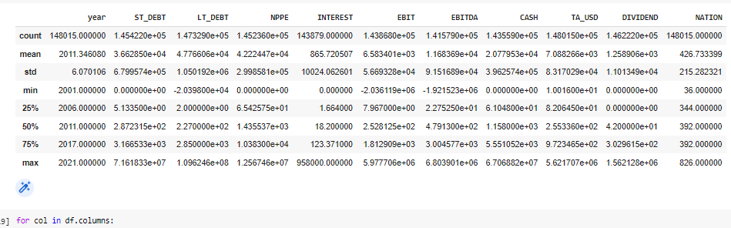

# CORRELATION AND REGRESSION ANALYSIS

* 1. **CORRELATION ANALYSIS**

The purpose of correlation analysis is to establish the existence of a relationship between two variables or data sets and to measure the strength of any such relationship. This means that quantitative data collected from financial institutions is analyzed using correlation analysis to determine the existence of meaningful relationships, patterns, or trends. Using features in our dataset date maturity data of 2020, we were able to find out how these features correlates with one another. The primary goal of correlation analysis is to discover hidden relationships between data points. One interpretation of the correlation result is that as one variable rises, the other rises as well, whereas the other interpretation is that as one variable falls, the other rises. The correlation values lie between -1 to 1, where by, variables with values close to -1 have a high negative correlation, those with values close to 1, we say they have a high positive correlation and lastly those close to 0 have low positive or negative correlation depending of the sign of their values. Below is a table showing how these features correlates.

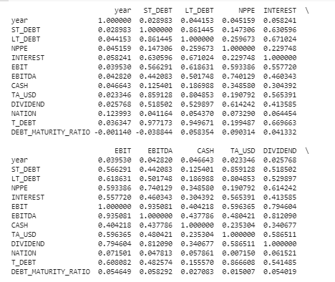

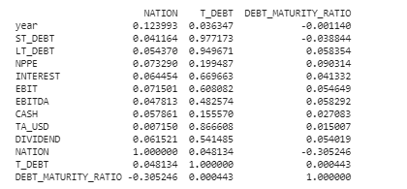

## Visualizations

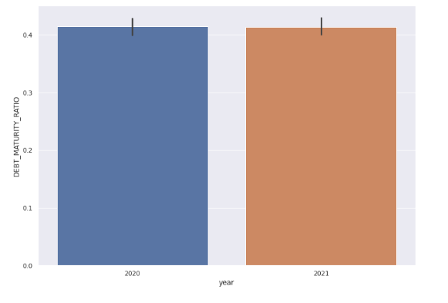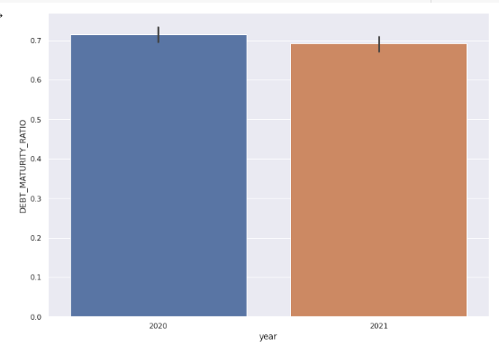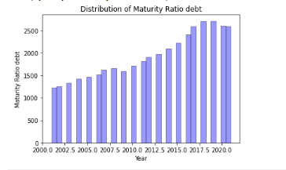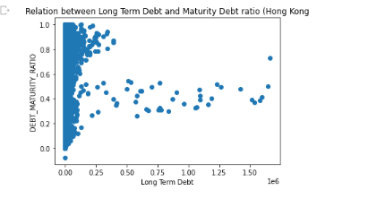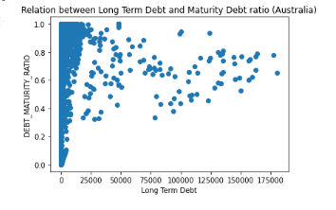

* 1. **REGRESSION ANALYSIS**

Country Australian, Year 2021

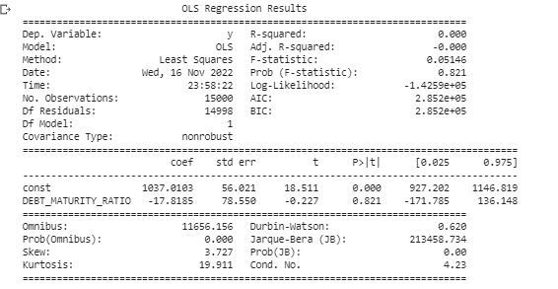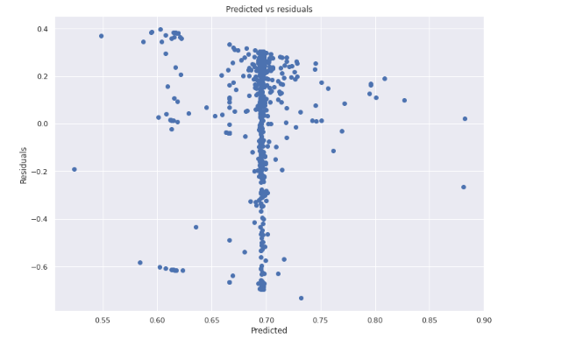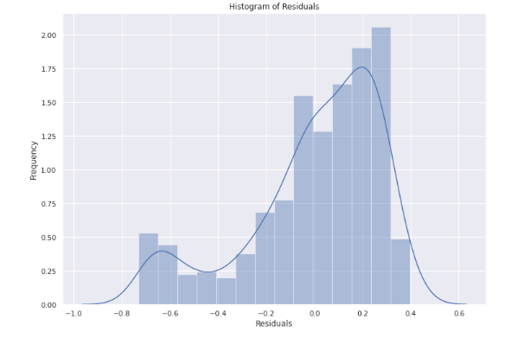

Country Hong Kong, Year 2021

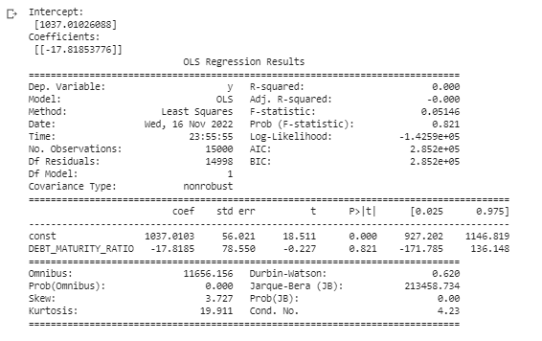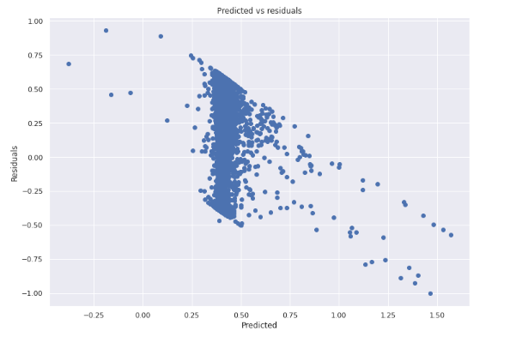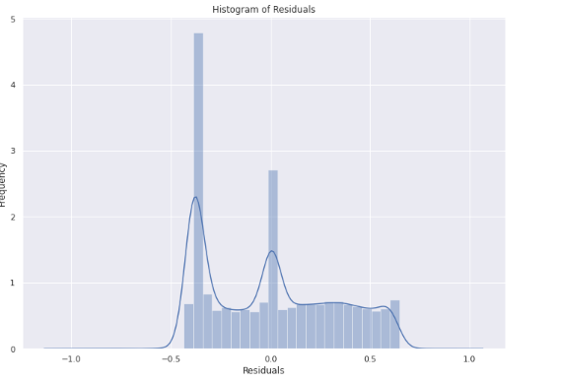

CODES SINPPETS

## select all rows where country is Australia

## we want to get debt maturity ratio column for this country only

maturity_australia = new_df.loc[(new_df['COUNTRY'] == 'Australia')]

maturity_australia

## select all rows where country is Hong Kong

## we want to get debt maturity ratio column for this country only

maturity_hong = new_df.loc[(new_df['COUNTRY'] =='Hong Kong')]maturity_hong

## maturity_hong dataset

import seaborn as sns

new_df_year = maturity_hong.loc[(maturity_hong['year'] == 2020) | (maturity_hong['year'] == 2021)]

sns.set(rc={'figure.figsize':(11.7,8.27)})

sns.barplot(x="year",y="DEBT_MATURITY_RATIO",data=new_df_year)

plt.show()

CONCLUSIONS

Multiple linear regression and simple linear regressions were used in

RERENCES

Schumaker, R. P., Zhang, Y., Huang, C.-N., & Chen, H. (2012). Evaluating sentiment in financial news articles. Decision Support Systems, 53 (3), 458–464.

Fang, B., & Zhang, P. (2016). Big data in finance. In *Big data concepts, theories, and applications* (pp. 391-412). Springer, Cham.

Kumar, S., Sharma, D., Rao, S., Lim, W. M., & Mangla, S. K. (2022). Past, present, and future of sustainable finance: insights from big data analytics through machine learning of scholarly research. *Annals of Operations Research*, 1-44.

Andriosopoulos, D., Doumpos, M., Pardalos, P. M., & Zopounidis, C. (2019). Computational approaches and data analytics in financial services: A literature review. *Journal of the Operational Research Society*, *70*(10), 1581-1599.

Ravi, V., & Kamaruddin, S. (2017, December). Big data analytics enabled smart financial services: opportunities and challenges. In *International Conference on Big Data Analytics* (pp. 15-39). Springer, Cham.

Song, H., Li, M., & Yu, K. (2021). Big data analytics in digital platforms: how do financial service providers customise supply chain finance? *International journal of operations & production management*.

Lessmann, S., Baesens, B., Seow, H.-V., & Thomas, L. C. (2015). Benchmarking state-of-the-art classification algorithms for credit scoring: An update of research. European Journal of Operational Research, 247 (1), 124–136.